Experiment 1 : Hands on Multimeter and Breadboard.

Circuit Diagram :

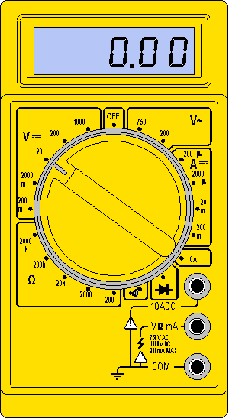

MULTIMETER

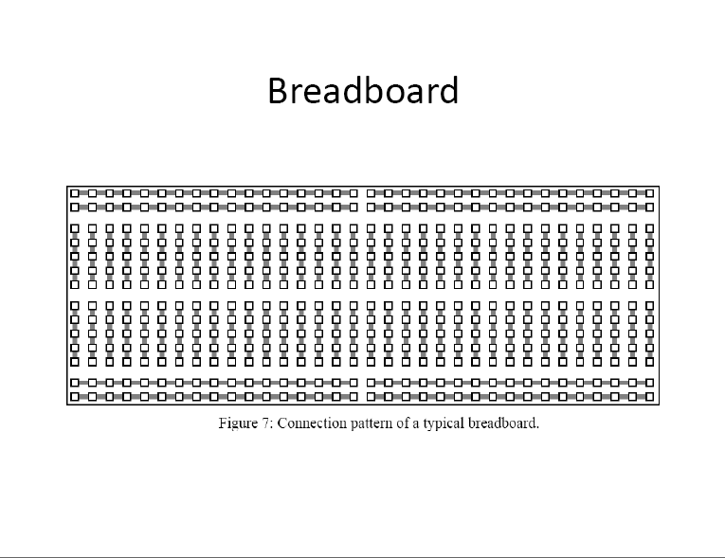

BREADBOARD

***THEORY***

***Multimeter:***

* A multimeter is a device used to measure voltage, resistance and current in electronics & electrical equipment
* It is also used to test continuity between to 2 points to verify if there is any breaks in circuit or line
* There are two types of multimeter Analog & Digital
  + Analog has a needle style gauge
  + Digital has a LCD display

***Breadboard***:

A breadboard is a solderless device for temporary prototype with electronics and test circuit designs. Most electronic components in electronic circuits can be interconnected by inserting their leads or terminals into the holes and then making connections through wires where appropriate.

***Concept Used:***

Firstly: We have to turn off the multimeter .

Second : Check the connections that black wire is in commom port and other wire is the desired port which we have to measure. Put the regulator on that symbol.

Third : Put one wire of multimeter on each terminal of the object and other wire on other terminal.

Now observe the reading displayed on display.

***Learning and Observation:***

In this Experiment we learned about how to measure

1 Voltage

2 Current

3 Resistance

4 Connectivity of a wire

5 Potential drop of a diode , LED by multimeter.

And Make circuit without soldering the wires, led’s and resistors by using Breadboard.

***Problem and troubleshooting:***

If the multimeter is unable to switch on then

Troubleshoot it by checking that the battery is inserted or not,and the inserted battery is charged .if not charged then replace it by new one.

***Precautions :***

1 Always start measuring the values from the highest range given in the multimeter . Otherwise the multimeter may get damaged.

2 Make sure that the area where you are performing the experiment must dry .

***Learning Outcomes:***

We have learned many skills by this experiment

1 To Connect many wires and electrical equipment in series or parallel without soldering with the help of Breadboard.

2 To measure the voltage, current, potential drop and resistance of electrical equipments.

3 To check the connectivity of the circuit by multimeter.